Functional Specification

Year: 2025 Semester: Spring Team: 9 Project: Fairway Finder

Creation Date: January 21, 2025 Last Modified: January 25, 2025
Member 1: Saxon ZumBerge Email: szumberg@purdue.edu
Member 2: John Stanwick Email: jstanwic@purdue.edu
Member 3: Marcus Good Email: mrgood@purdue.edu

Member 4: Liam Kauffman Email: wkauffma@purdue.edu

Assignment Evaluation: See Rubric on Brightspace Assignment

1.0 Functional Description
The autonomous golf caddy is a portable, self-driving device designed to carry a golfer's bag and follow them throughout a golf course. It provides hands-free assistance, allowing users to focus entirely on their game without the physical strain of transporting heavy equipment. The device performs the following primary functions:

Primary Functions
- Follow-Me Navigation
  - The caddy autonomously tracks and follows the user while maintaining a safe and consistent distance.
  - It avoids obstacles in real-time to ensure uninterrupted movement and avoid collisions.
- Golf Bag Transportation
  - Securely holds a standard golf bag up to 50 lbs
  - Withstands typical golf course terrains
- Obstacle Detection and Avoidance
  - Navigates around obstacles on golf course
  - People, trees, rocks, etc.
- User Interaction
  - Simple controls (e.g., power on/off, pause/resume, and manual override) allow the user to interact with the caddy.
  - Simple status and alerts communication (e.g., low battery, obstacle detection, moving in reverse)
- Portability
  - Designed for easy transport to and from the golf course, with a compact design suitable for storage in vehicles.
- Power Management
  - Operates for an entire game (approximately 4–5 hours) on a single battery charge
- Include app
- Need more granulatirity be mroe specific with these in a bulleted list

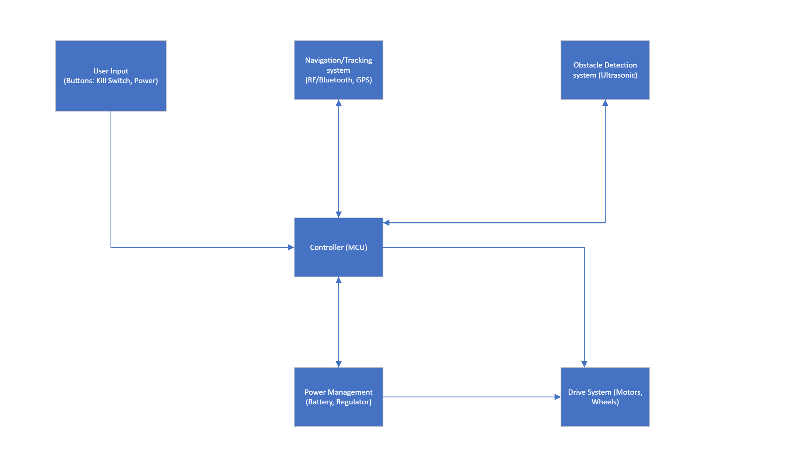

Figure 1: System Block Diagram

2.0 Theory of Operation

Pulse Width Modulation (PWM)

Pulse width modulation varies the duty cycle of a “pulse” as can be seen in figure 2 [5]. This changes the average value of the output voltage wave, and thus the current pulled by the load. This means that a higher duty cycle means a higher power and vice versa. With a 50% duty cycle the average voltage will be ½ of the supply voltage. Finally, the signal is output at a high enough frequency that load essentially only experiences the average voltage value as its supply. This signal will be used significantly by the microcontroller to ensure motor control & power electronic circuits can function properly.

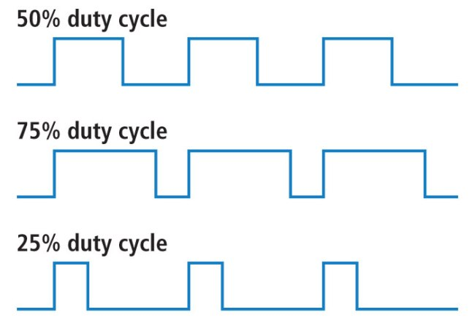

Figure 2: Pulse Waves with Varying Duty Cycles

H-Bridge Motor Control

To achieve motor control an H-bridge circuit will be used. This will allow the microcontroller to direct the motors to rotate forwards, backwards, and brake. As seen in figure 3 there are four transistors (Q1 to Q4), four flyback diodes (D1 to D4), a battery connection, a ground connection, and finally the DC motor in the middle. The transistors are used as switches to control the polarity of the current flow to the motor. If Q1 and Q4 are closed, the motor will spin “forwards” (depending on the motor's physical orientation of the robot). This is because the current will flow from the battery through Q1 to the motor to Q4 and finally to ground. To go backwards close Q3 and Q2 which will ensure the current flows through the motor in an opposite polarity, causing the motor to spin the other direction. To break (slowly, relative to reversing the motors) simply turn off all transistors and thus cut the power to the motor. The flyback diodes will protect other components from the inductive voltage spike from the motor. To keep the circuit & control of the motor as efficient as possible a pulse width modulation signal will be used as the gate voltage to the Q1 to Q4 MOSFETs. Without PWM the MOSFET transistors will have a much higher resistance value (~1-10ohms) as they operate within the linear region causing a significant amount of power loss due to heat. However, with PWM the MOSFET transistors will operate in the saturation region where the Rds,on value is in the hundreds of milliohms region according to Texas Instruments [3]. The motor will be on for as long as the duty cycle’s amplitude is greater than the threshold voltage for the transistors. For nMOSFETs the voltage threshold will be positive and for pMOSFETs the voltage threshold will be negative.

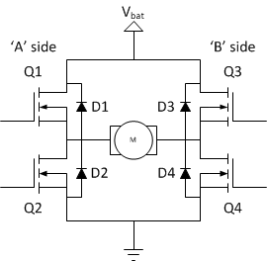

Figure 3: Basic H-Bridge Circuit

Power Management (Battery & Buck Converter & Low Dropout Regulators)

Battery

The robot will use a lithium-ion battery as its power source likely at 12 or 24VDC. This voltage will minimize the batteries weight, resistive losses, and the acceleration response of the motors. However, it will mean that in order to achieve between 3.3V and 5V for sensors, the microcontroller, and any other electrical equipment a buck converter will be required.

Buck Converter

The buck converter circuit seen below will be used to step the battery voltage down. The circuit consists of a nMOSFET transistor (S1), forward biased diode, inductor, and capacitor. A PWM input signal (with a specific duty cycle) to the transistor will switch it on and off. The inductor and capacitor will store energy in their magnetic and electric fields to maintain a stable voltage through the transistor’s toggling. When the current is zero (transistor is off) which will cause a large voltage spike from the inductor as it releases its energy into the circuit (see equation 1). When the voltage begins to decrease the capacitor will release current (aka energy) according to equation 2 to stabilize the voltage. This creates a stable DC voltage output to the load. Finally, the circuit is only ~90% efficient which will lead to some energy loss [3].

$$V_{L}=L*\frac{di}{dt}$$

Equation 1: Inductor VI Relationship

$$I_{C}=C*\frac{dv}{dt}$$

Equation 2: Capacitor VI Relationship

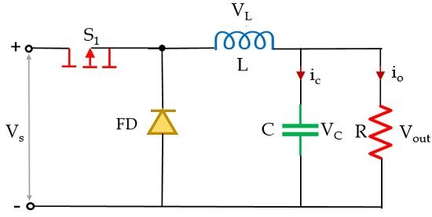

Figure 4: Buck Converter Circuit

Obstacle Avoidance

The FairwayFinder’s obstacle avoidance system uses ultrasonic sensors and the A* path planning algorithm to enable autonomous navigation. Ultrasonic sensors measure the distance to obstacles by emitting sound waves and calculating the round-trip time of the echo. The distance d to an obstacle is calculated using the formula d = ½ * v * t, where v is the speed of sound in air (343 m/s) and t is the time of flight. The sensors continuously provide distance data to the microcontroller, which processes this information in real-time to detect obstacles. When an obstacle is detected, the microcontroller uses the A* algorithm to find the optimal path by evaluating the total cost function f(n) = g(n) + h(n), where g(n) is the cost to reach the current node and h(n) is the heuristic estimate to the goal. The robot dynamically adjusts its path and speed based on the updated path from the algorithm, ensuring it avoids obstacles while following the user. The mobile app communicates the robot’s target position, and the microcontroller integrates the sensor input with path-planning logic to maintain continuous movement and obstacle avoidance throughout the course.

Bluetooth communication
The FairwayFinder robot communicates with the phone using Bluetooth Low Energy (BLE), operating in the 2.4 GHz ISM band. BLE employs Frequency Hopping Spread Spectrum (FHSS) to reduce interference from other devices. In this setup, the phone acts as the central device, while the robot’s microcontroller functions as the peripheral. The communication process begins with the phone scanning for the robot and establishing a connection. Once connected, the phone sends control commands, such as movement directions, which the microcontroller decodes and processes. The microcontroller then adjusts the robot’s behavior accordingly.

3.0 Expected Usage Case

Environmental Conditions
The autonomous golf caddy is designed to operate in outdoor environments typical of golf courses. Key environmental conditions include:
- Terrain: Grass, inclines, and uneven surfaces.
- Weather: Extended exposure to sun, wind, and humidity. Moderate exposure to rain
- Temperature Range: Expected to function between 30°F and 110°F.
- Obstacles: Trees, other players, carts, and course infrastructure (benches, signs, etc.).

Portability
- Able to be easily transported to and from the course
  - Parking lot to first tee
  - Car to garage
  - Light enough to push if battery dies
- Compact enough to fit in at a minimum midsize sedan car trunk
  - 14 cubic feet

Number of Users
- One user is expected to interact with the golf caddy at a time

Nature of Users
- Expected ages of 15-75 years old (teenagers to elderly adults)
- Physical Characteristics: Users may have varying physical capabilities. The autonomous caddy should assist individuals who may find pushing or pulling a golf cart physically demanding.
- Technical Literacy:
  - Users are expected to have basic technical literacy sufficient to:
    - Power on/off the device
    - Operate a smartphone app
    - Pair it with a smartphone
    - Troubleshoot simple issues (e.g., reconnecting Bluetooth).
  - Simplicity is key
    - Caddy will feature intuitive controls and minimal setup requirements

Assumption about Users
- Users are likely focused on their golf game and may have limited attention to spare for managing the caddy. As such, the device must operate autonomously and reliably with minimal user intervention.
- Users value durability, reliability, and ease of use over complex features.
- Users are accustomed to carrying golf bags that weigh up to 30-50 pounds, so the caddy must accommodate this weight comfortably.

4.0 Design Constraints

4.1 Computational Constraints

Real-time Obstacle Detection and Path Planning:

- Ultrasonic sensors continuously collect data at 40-100 Hz.
- A* pathfinding algorithm evaluates several hundred nodes per second to calculate the optimal path.
Memory Constraints:
- Microcontroller must store real-time sensor data (~100-200 bytes per cycle) and algorithm states (approx. 1-2 KB).
- Memory must support real-time pathfinding and communication with the mobile app (requiring at least ~32-64 KB of RAM).

4.2 Electronics Constraints

The following major project components will be included with the project.

STM32 microcontroller with the following capabilities:

Bluetooth Module

Pulse Width Modulation

I2C

GPIO

SPI

Ultrasonic Sensors

HC-SR04

Push Button

Acts as “kill switch” to turn off robot

Light Emitting Diode

Robot on/off Status

Inertial Measurement Unit

Accelerometer

Gyroscope
The STM32 microcontroller will be equipped with a Bluetooth module, PWM, I2C, GPIO, and SPI communication capabilities. Ultrasonic sensors, HC-SR04, will be used, and a push button will act as a “kill switch” to turn off the robot. A LED will indicate the robot’s on/off status, while an IMU with an accelerometer and gyroscope will provide necessary motion data. A primary constraint for the ultrasonic sensors is that if the sound waves hit an object at an angle where they don't return correctly, the sensor will yield an inaccurate reading. Therefore, any control software must account for this potential issue.

4.3 Thermal/Power Constraints

Maximum operating temperature of 110 degrees fahrenheit

Heat sinks required on high power electrical components (MOSFETs)

Airflow with dust & water filters on chassis

Reflective paint coloring for sunlight

Battery Specifications

4 miles at 3 mph

Operational for at least 300 full battery cycles

Charging time of 5 hours or less

Buck Converter
Thermal and power constraints for the project are influenced by the operating environment and battery requirements. The system must operate at a maximum temperature of 110°F, with heat sinks required on high-power components such as MOSFETs. The chassis will include dust and water filters, and reflective paint will be applied to reduce heat from sunlight. The battery needs to support at least 4 miles of travel at a speed of 3 mph and should last for at least 300 full battery cycles. It should also have a charging time of 5 hours or less. A buck converter will be used to convert the battery’s 12 or 24VDC down to a lower voltage for the microcontroller and other system components. A LDO will be employed to initially power the microcontroller on startup. After that, the buck converter will be controlled by the microcontroller to efficiently power the system.

4.4 Mechanical Constraints

Caddy maximum weight of 35 pounds (no golf bag)

Fit within 14 cubic foot car trunk (midsize sedan)

Dustproof

Water resistant for light to moderate rain

Heat reflective paint

Operate between 30 degrees to 110 degrees Fahrenheit

Navigate golf course terrain

Hills up to 10-degree slope

Avoid trees, sand traps, green (at a minimum through manual control)

4.5 Economic Constraints

The total estimated cost is $350. Key components include a $50 microcontroller and custom PCB for power and communication, $50 for motors and motor controllers, and $100 for sensors like ultrasonic and RF/GPS modules for navigation. The battery system, providing a 4+ mile range, is also estimated at $100. The chassis and frame will be custom designed with minimal cost, and software development will be handled internally without additional expenses. A $50 miscellaneous budget accounts for spare parts and unforeseen costs. This budget ensures the robot can perform efficiently within financial constraints and also remains cheaper than existing alternatives outlined in initial project scope.

5.0 Sources Cited:

[1] Last Minute Engineers, "Interfacing HC-SR04 Ultrasonic Sensor with Arduino," Last Minute Engineers, Dec. 19, 2017. [Online]. Available: https://lastminuteengineers.com/arduino-sr04-ultrasonic-sensor-tutorial/. [Accessed: Jan. 25, 2025].

[2] Modular Circuits, "H-bridges: The Basics," Modular Circuits, [Online]. Available: https://www.modularcircuits.com/blog/articles/h-bridge-secrets/h-bridges-the-basics/. [Accessed: Jan. 25, 2025].

[3]RECOM Power, REC-N Buck Switching Regulators: Principles, Performance, and Applications, [Online]. Available: https://recom-power.com/en/rec-n-buck-switching-regulators-principles,-performance,-and-applications-396.html. [Accessed: Jan. 25, 2025].

[4] Texas Instruments, CSD17312Q5 NexFET™ Power MOSFET Data Sheet, Rev. C, Sep. 2020. [Online]. Available: https://www.ti.com/lit/ds/symlink/csd17312q5.pdf. [Accessed: Jan. 25, 2025].

[5] U.S. News, "Honda Accord Interior: Features, Dimensions, and Comfort," U.S. News & World Report. [Online]. Available: https://cars.usnews.com/cars-trucks/honda/accord/interior#:~:text=%22The%20Accord's%20front%20seats%20support,16.7%20cubic%20feet%20of%20cargo.%22&text=%22Trunk%20space%20of%2016.7%20cubic,is%20similarly%20class%2Dleading.%22. [Accessed: Jan. 25, 2025].

[6] SparkFun Electronics, Pulse Width Modulation, [Online]. Available: https://learn.sparkfun.com/tutorials/pulse-width-modulation/all. [Accessed: Jan. 25, 2025].

[7] [1]A. Patel, “Introduction to A*,” theory.stanford.edu, 1997. https://theory.stanford.edu/~amitp/GameProgramming/AStarComparison.html

[8]“Ultrasonic Sensor - an overview | ScienceDirect Topics,” www.sciencedirect.com. https://www.sciencedirect.com/topics/engineering/ultrasonic-sensor

[9]M. Afaneh, “Bluetooth Low Energy (BLE): A Complete Guide,” Novel Bits, Sep. 06, 2022. https://novelbits.io/bluetooth-low-energy-ble-complete-guide/
‌

